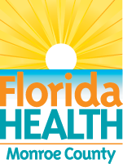

Revive Awareness Day offers free Narcan

The Florida Department of Health-Monroe County will host a free Narcan distribution drive at the Winn-Dixie in Marathon, from 11 a.m. to 2 p.m., on Friday, June 5, as part of Revive Awareness Day.

Naloxone, also known as Narcan, is a medication often used for opioid overdose.

This year’s event, in partnership with the Guidance/Care Center and Monroe County Coalition, will provide participants with overdose prevention education, including spotting the signs of an overdose, how to use Narcan and resources available to support those with substance abuse issues.

The medication will be available will supplies last, according to DOH-Monroe.

In addition to the Marathon event at Winn-Dixie, 5585 Overseas Highway, other locations throughout the Florida Keys will participate.

For information, visit monroe.floridahealth.gov, email DOHMonroe@flhealth.gov or call DOH-Monroe at 305-293-7500.

